# **8.4 Guided Exercise: Scanning for Viruses**

|  |  |
| --- | --- |
| **Resources** | |
| Files | trojansimulator.zip |
| Machines | Windows 10 |

In this exercise, you are required to scan a zip file with an antivirus and identify if the file is malicious.

Open the desktop folder called Exercises and then the folder Malwarebytes. Double click the file mb3-setup-consumer, to install Malwarebytes.

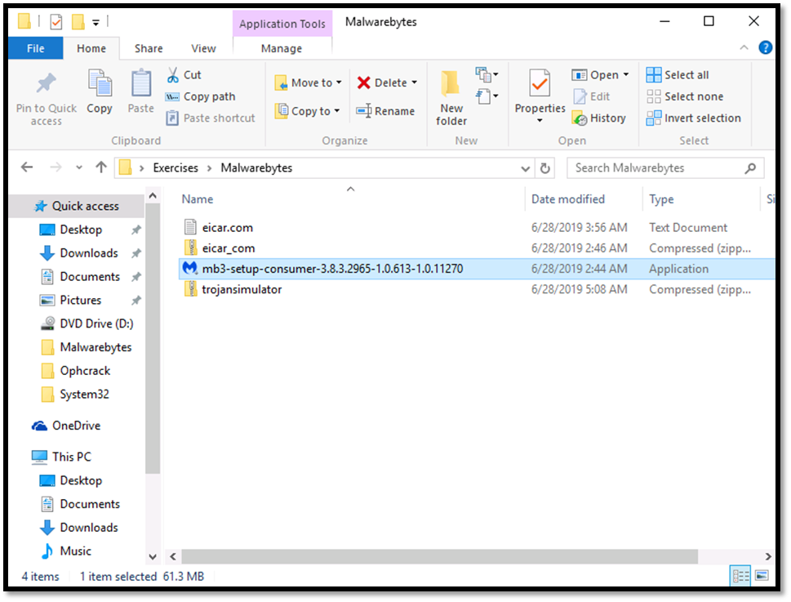

On the windows Open File – Security Warning select Run.

On the User Account Control windows select Yes.

Click OK on the Select Setup Language

On the Setup – Malwarebytes window Select Personal computer and then click Continue

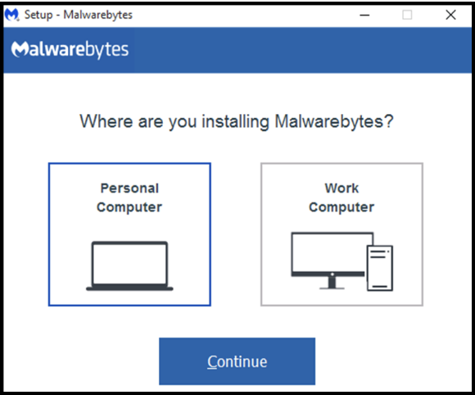

Click Agree and Continue on the Setup – Malwarebytes window.

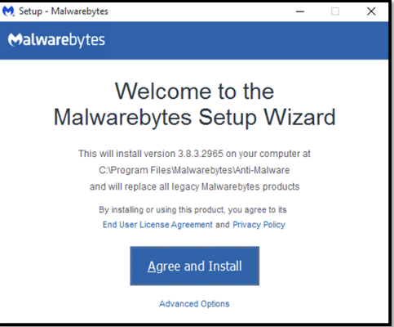

Once the installation finishes click Finish on the Setup – Malwarebytes window

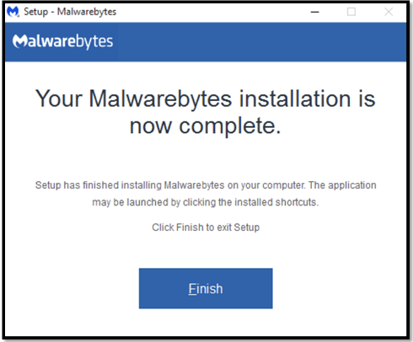

Click Scan Now on the Malwarebytes window. If you get a warning for network error just ignore it after the scan finishes.

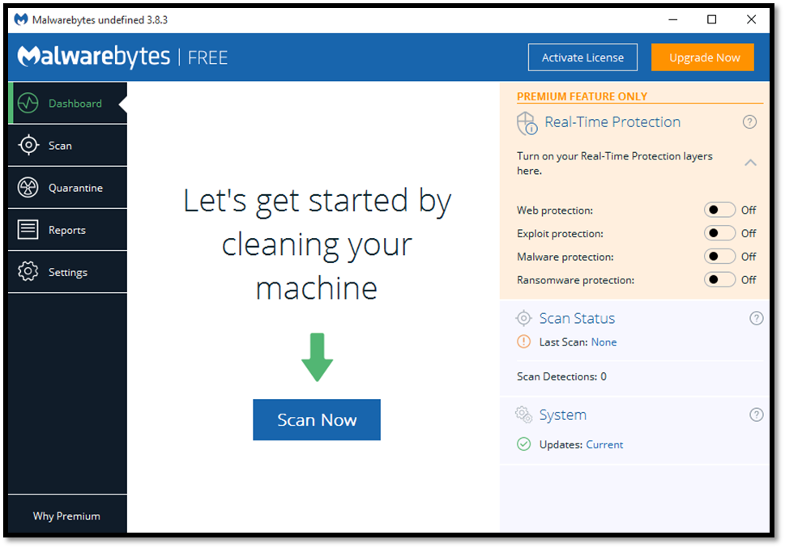

Once the scan finishes you can observer that Malwarebytes was able to identify the file trojan simulator as a malicious file.

